Preface

This book is a summary of political and sociological topics that I have dealt with in recent years and about which I have written various articles in Astrology Today and Meridian. Due to the emergence of the coronavirus and the events in Ukraine, the topics gain a new explosiveness, which is why I have fundamentally revised them.
The war in Ukraine has many causes. Similar to the complexity that led to World War I, there are many actors with different interests. The West has long courted Putin and tolerated his increasingly despotic behavior. The United States and Europe have also been at odds over their stance. While American think tanks sought to talk to the opposition in Ukraine before the Euromaidan, the Germans in particular did not want a conflict with Russia. Former Chancellor Gerhard Schröder had fixed a new pipeline deal with Russia that would guarantee independence from the ones going through Poland and Ukraine. There is a strange disorientation of today's decision-makers about the questions of the future. The Ukraine war exposes the life lie of a whole generation.
With Jupiter and Neptune in pisces religiously dressed up moralizers dominate the discourse and a return of despots can be observed. In times of crisis, people like to cling to the 'strong man'. Fears are deliberately stirred up in order to make a profit for the respective interest group. The culture of debate has suffered from this and from increasing aggressiveness. Resonance appears as an end in itself, promises are made and not kept. The students, the workers and the employees are lured into believing that their needs will be met, and yet they have become only voiceless parts of a self-automating process. Scientific work is funded within the very narrow bounds of economic constraints. There are many findings, but hardly any results that do justice to the human catastrophe.
The sober transition to the 'digital era' with the beginning of the cycle of Saturn and Pluto in Capricorn seems logically compelling, but is emotionally elusive. The sometimes-ponderous nature of Capricorn and the insistence on reason are simply not en vogue, even after years of flailing. Had Corona not come along, we probably would have gone on like this for a long time. But with the threat of the virus, a whole host of measures have been taken that have slowed life down and given nature a rest. Policymakers can decide on things that would have been economically unthinkable before. In a very deadly mass epidemic similar to the plague, we would not have had the leisure to also think about all that was happening, to deepen our relationships and to take care of things that were left lying around. Then we would have been busy with pure survival. And the Ukraine war finally brought to the fore, that we felt swoop the dependence on fossil fuels; the majority of which in the world are owned by autocratic systems.
But to seize the opportunity of the crisis, we also need to fix the behavioral changes. In view of the upcoming challenges with soon 8 billion people on a not expandable planet, we should learn to dream again, and also to imagine impossible things, just like Alice behind the mirrors. In this way, we can find new solutions that come from ancient programs. When Alice doubted the white queen that such a thing was possible, the queen replied, "You will not have had the proper practice. At your age, I spent half an hour a day on it. At times, before breakfast, I already believed up to six impossible things." This imagining and opening to impossible facts is necessary, because at the same time we are experiencing technologically rapid changes, the effects of which we cannot yet estimate. The fight against the virus made it possible to implement digitalization more quickly than anyone would have thought possible before. Schools and universities are being upgraded with electronic learning materials, jobs are being rationalized away for machines, and processes of social life in all areas are being irrevocably electrified and placed under the guidance of artificial intelligences. Our world is not only undergoing a crisis but a complete transformation.
The Corona virus and the following Ukrainian war has brought us into contact with subjects concerning about a totalitarian development of society. For it must remain fundamentally possible, even in spite of viruses, environmental catastrophes and war dangers, to lead one's life analogously, to realize locally divergent structures within this electronic network and to behave critically toward the 'brave new world'. For this still functions according to the rules of the cold profit maximization logic of the media moguls, cyber warlords and industrial typhons of the early days of industrialization. The Patent Protection Act grants them the right not to give us any insight into how technology will be used in the future. But in the digital world, the analog tools of democracy should also remain transparently accessible, and not everyone should have to have a lawyer and computer science degree to do their tax returns.
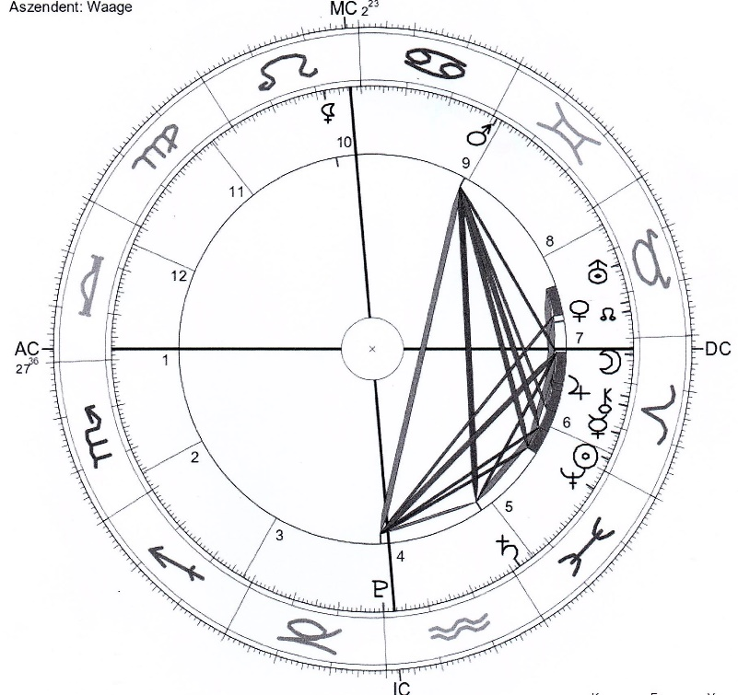
Horoscope 1: Pluto Ingress Aquarius
03/23/2023, 20:30, Beijing, China
Given the many unresolved issues of our time, it is very difficult to become aware of a personal value and find a clear position. A new 'cancel culture' (denunciation culture) is spreading, which makes personality formation difficult, since hardly anyone except activists dares to take a clear position anymore. The concerns of Black Live Matters, Yellow Vests, Fridays for Future, #me-too and many other movements that have taken to the streets in recent years are to be taken seriously. But so far there is no common thread connecting them, and their offshoots are tugging at the rule of law and undermining the institutions of states. At the same time, a struggle for the interpretive sovereignty of symbols is taking place. It is no longer permitted to use certain terms that may offend marginalized groups or individuals. Many young people are turning to the idea of non-binaries and rejecting gendered characteristics.
When Pluto enters Aquarius in 2023, peer pressure will continue to rise, making new political struggles inevitable. The two world powers, the U.S. and China, are at a stalemate, spending huge sums on military and new technologies in a new cold war. At the same time, small self-organized cells of people are forming all over the world that do not consume new resources in harmony with the environment. The art is to find peaceful and intelligent solutions to the fundamental upheaval of society that lies ahead. Solutions that also draw on old knowledge and do not have to constantly reinvent the wheel. In this also astrology can receive an increased portion. For it has always reconsidered the consequences of civilizing actions and the accompanying psychological compensation patterns and has herself survived many catastrophes.
Capitalism is not over yet. But the meltdown of capital will happen on its own and the market will regulate the surpluses itself. As soon as there are no more big growth areas, the economy will turn to efficiency programs and develop a kind of planned economy like in the communist countries with the difference that they run through democratic processes. It will not be easy for people to voluntarily do without in a post-growth society, but it will be all the easier for them because they will be involved in the crucial structures. Robotics and genome technology will be drivers for new markets, but they can be kept going in any small village anywhere in the world. According to the meaning of Pluto in Aquarius, this will make people a bit more equal, but the dislocations in the individual who cannot keep up with technological progress will become greater.
Placing the horoscope on Beijing as the coming technological world power, we see that all planets except Lilith and Pluto are on the right side of the chart. The opposite is true if we place the ingress of Pluto in Aquarius on Washington. There all planets are on the left side. This antagonism symbolizes the competition of the two superpowers for technological supremacy. Pluto is at the IC at the lowest point in the chart, indicating the revolutionary forces with which China will change the world. The Libra AC corresponds to the Far Eastern mentality of calmness and balance. With five planets in the sign of Aries, things are boiling violently. The Moon on the Descendant shows stronger emotional involvement than we have been used to. This process was initiated with Xi Yinping's speech on the occasion of his party's 100th birthday on January 11, 2021, where he emphasized that no one would be able to beat China again as in the colonial era. The Chinese people would never again allow foreign forces to "bully, oppress and subjugate" them. "Anyone who would try to do that will find himself on a collision course with a great wall of steel forged by 1.4 billion Chinese," the party chief said to cheers from 70,000 invited participants. He defended himself against foreign criticism, saying, "We will never accept hypocritical sermons from those who think they have the right to lecture us."
Xi Jinping had gathered with Chinese leaders on the balcony of Tiananmen Gate above the large portrait of revolutionary Mao Zedong at the entrance to the "Forbidden City." The scene recalled how the "Great Helmsman" had proclaimed the founding of the Communist People's Republic on the same spot in 1949. Xi Jinping similarly wore a gray Mao suit as he spoke at the podium with large microphones and a golden hammer and sickle. In his more than hour-long speech, the party leader also called for the modernization of the armed forces. "A strong nation must have a strong army," he said. He opposed "independence forces" in democratic Taiwan, which is considered part of the People's Republic, and called for "peaceful reunification" with the island. No one should underestimate China's determination and ability to defend its sovereignty and territorial integrity, he said. These vulnerable statements are also visible in the ingress chart through the conjunction of Jupiter and Chiron.
Chiron, this little miracle worker keeps coming up in the charts of our time, as we will see later, shows us the way to our true selves and to the issues where we can exist in an autonomous way. With its conjunction to Jupiter, the leader of the Pantheon, we have to arrange with authorities. In the sign Aries at the cusp to the sixth house this is very important the acceptance of the aggressive parts in us and the transformation of these sometimes-uncontrollable impulses to a co-determined and tolerant society. We are not machines and can make mistakes. But if their feelings are hurt, not only the Chinese will know how to defend themselves. The square of Sun and Mars, as well as the square of Moon and Pluto, do the rest to not let the spoken threats go unheeded.
The theme of powerlessness and limitation will be with us well beyond the Corona crisis and he Ukrainian war before we will be able to find a trusting relationship with the new technologies and among the new societies. Mars in Gemini in house 9 is focused on a new communication to the world. In the last degrees of this sign he possesses an extraordinarily keen and critical mind. The liberating position of Lilith in this chart gives hope. She is in leading position at the MC in the sign Leo and casts a supportive trigon to Mercury. In the 10th house, she is open to all proposals concerning an emancipated society. But with her opposition to Pluto we sometimes fail to integrate old unloved feelings and rejected personality parts of ourselves and will experience increased rejection. Pluto forces us to transform the unresolved revolting parts of our personality. This is his task during his ingress in Aquarius, which is associated with the emergence of an entirely new technology and society. How we can approach these issues astrologically is what this book aims to show.

American astrologer Dana Gerhardt brings this wonderful example on her blog from early 2021. https://mooncircles.com/2021s-impossible-dream-challenge-make-saturn-uranus-work-for-you/
This leads to exaggerations, such as the rejection of a singer at a concert of the Friday Movement in Germany, because as whites she would wear Rastas. These have recently become a hallmark of African resistance movements. Nor should people dress up as Indians at carnival.
People born in the last degrees of Gemini are especially critical of false ideologies. Jean Paul Sartre founded existentialism and opposed the principle of hope. Blaise Pascal discovered the void in space, developed the principle of communicating tubes and wrote bitter polemics against the Jesuits. And Eugen Drewermann polarized within the church until he was expelled from it.

